***NAME – KHUSHI PANWAR, khushipanwar26@gmail.com***

***ROLL NO – 33***

***C++ PRACTICAL ASSIGNMENT – 09 DEC 2021***

**#1 WAP that uses Manipulators : endl,dec,oct,hex,fixed,showpoint,setw(),setprecision(), setfill():**

#include<iostream>

#include<iomanip>

using namespace std;

int main(){

int num1=123;

cout<<setw(60)<<"___ DEALING WITH MANIPULATORS ___"<<endl;

cout<<setw(60)<<"[ endl, dec, oct, hex, fixed, showpoint, setw(), setprecision(), setfill() ]"<<endl;

cout<<"\nValue of num1 : "<<num1<<endl;

cout<<"num1 as decimal : "<<dec<<num1<<endl;

cout<<"num1 as octal : "<<oct<<num1<<endl;

cout<<"num1 as hexadecimal : "<<hex<<num1<<endl;

float num2=123.456;

cout<<"\nValue of num2 : "<<num2<<endl;

cout<<"\nnum2 with width 10 : "<<setw(10)<<num2<<endl;

cout<<"num2 with fill character : "<<setw(10)<<setfill('*')<<num2<<endl;

cout<<"\nnum2 as fixed floating point decimal : "<<fixed<<num2<<endl;

cout<<"num2 with set preicision value 2 : "<<setprecision(2)<<num2<<endl;

cout<<"num2 with the float point value (for 0 setprecision) : “<< setprecision(0) << showpoint <<num2

<<endl;

return 0;

}

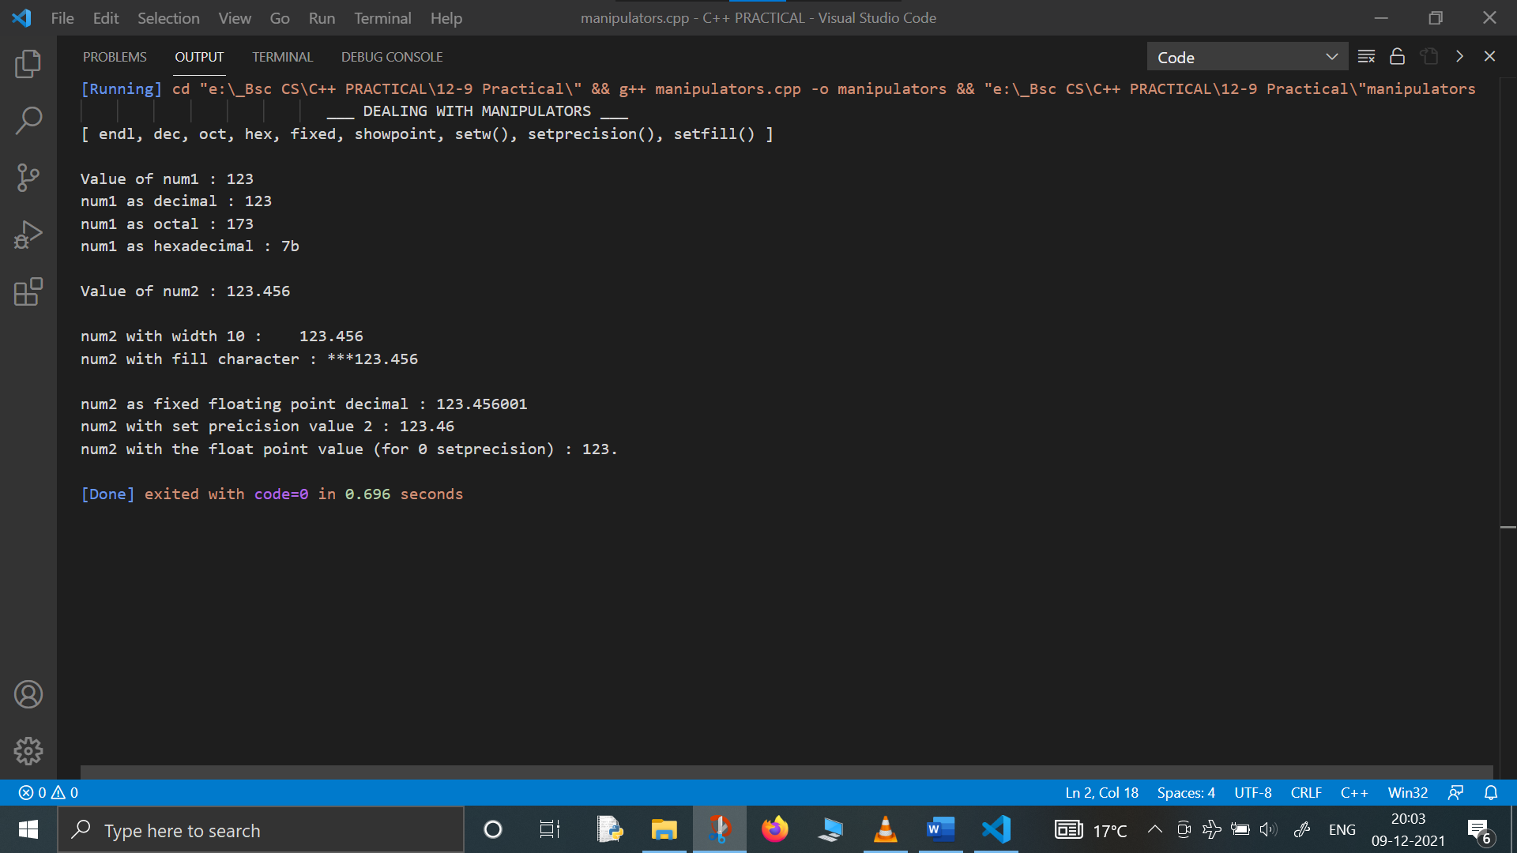

**#2- WAP to test the Post and pre increment and decrement operators:**

#include <iostream>

using namespace std;

int main(){

cout<<"** POST AND PRE INCREMENT AND DECREMENT OPERATORS **"<<endl;

cout<<endl<<"__POST INCREMENT, DECREMENT OPERATORS__"<<endl;

cout<<endl;

int a=15;

cout<<"Value of a : "<<a<<endl;

cout<<"Value of a++ : "<<a++<<endl;

cout<<"NEW Value of a : "<<a<<endl;

cout<<endl;

int b=10;

cout<<"Value of b : "<<b<<endl;

cout<<"Value of b-- : "<<b--<<endl;

cout<<"NEW Value of b : "<<b<<endl;

cout<<endl;

cout<<endl<<"__PRE INCREMENT, DECREMENT OPERATORS__"<<endl;

cout<<endl;

int c=20;

cout<<"Value of c : "<<c<<endl;

cout<<"Value of ++c : "<<++c<<endl;

cout<<"NEW Value of c : "<<c<<endl;

cout<<endl;

int d=30;

cout<<"Value of d : "<<d<<endl;

cout<<"Value of --d : "<<--d<<endl;

cout<<"NEW Value of d : "<<d<<endl;

cout<<endl;

return 0;

}

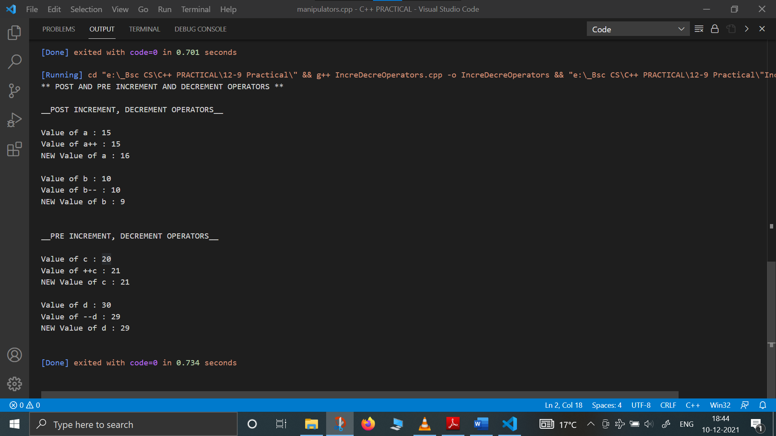

**#3 Program to find sum of numbers from 1 to n using for loop:**

#include <iostream>

using namespace std;

int main(){

int n, i ;

int sum=0;

cout<<"This program calculates the sum of numbers from 1 to n"<<endl;

cout<<"\nEnter the value of n : ";

cin>>n;

for (i=1 ; i<=n; i++) {

sum=sum+i;

}

cout<<"Sum of numbers from 1 to "<<n<<" is : "<<sum;

return 0;

}

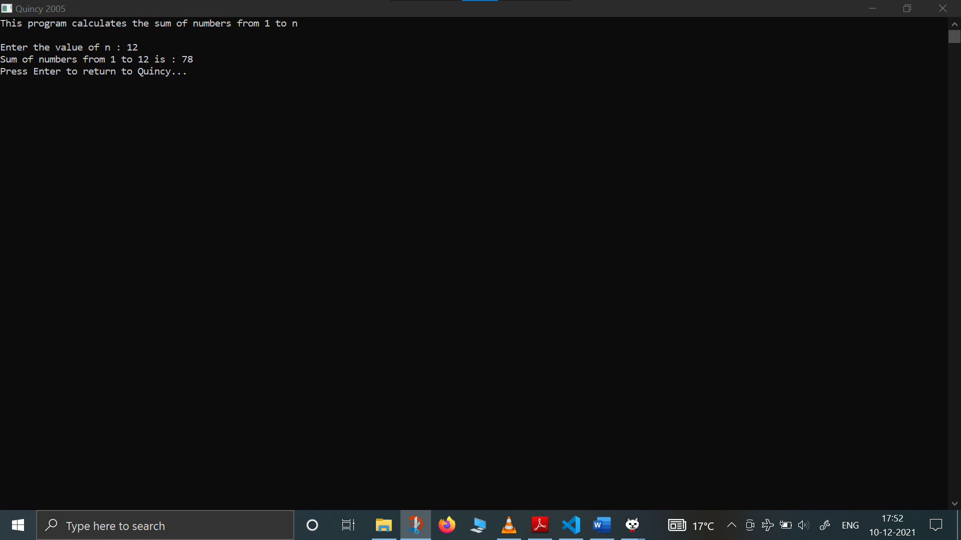

**#4- Write a C++ program that check if the input is prime number or not:**

#include<iostream>

using namespace std;

int main(){

cout<<setw(100)<<"__THIS PROGRAM CHECKS IF THE NUMBER IS PRIME OR COMPOSITE__"<<endl;

cout<<endl;

int k=0;

for (k=0;k<5;k++){

int num;

int flag=0;

cout<<"Enter the number : ";

cin>>num;

int i=2;

while(i<num){

if (num%i==0) { flag=1; }

i++;

}

if (flag==1)

cout<<num<<" is composite number (non prime) "<<endl<<"\n ------------*********------------\n"<<endl;

else

cout<<"The Number is Prime"<<endl<<"\n------------*********------------\n"<<endl;

}

return 0;

}

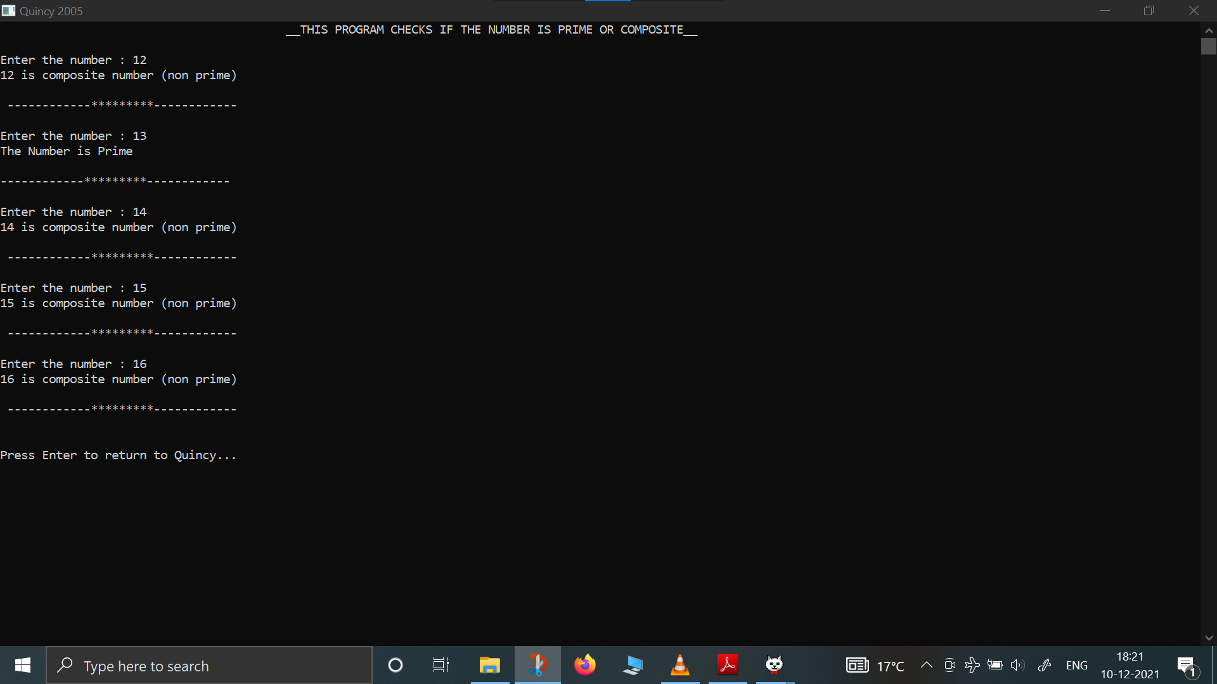

**#4- WAP to display the fibonacci series: 1 1 2 3 5 8…….n**

#include <iostream>

#include <iomanip>

using namespace std;

int main(){

cout<<setw(30)<<"___FIBONACCI SERIES___\n"<<endl;

int num, t1, t2;

cout<<"How many terms do you want in this fibonacci series : ";

cin>>num;

cout<<"Enter the first two series of Fibonacci series : ";

cin>>t1>>t2;

cout<<setw(4)<<t1<<setw(4)<<t2;

int n=3;

while (n<=num){

int sum=t1+t2;

cout<<setw(4)<<sum;

t1=t2;

t2=sum;

n++;

}

return 0;

}

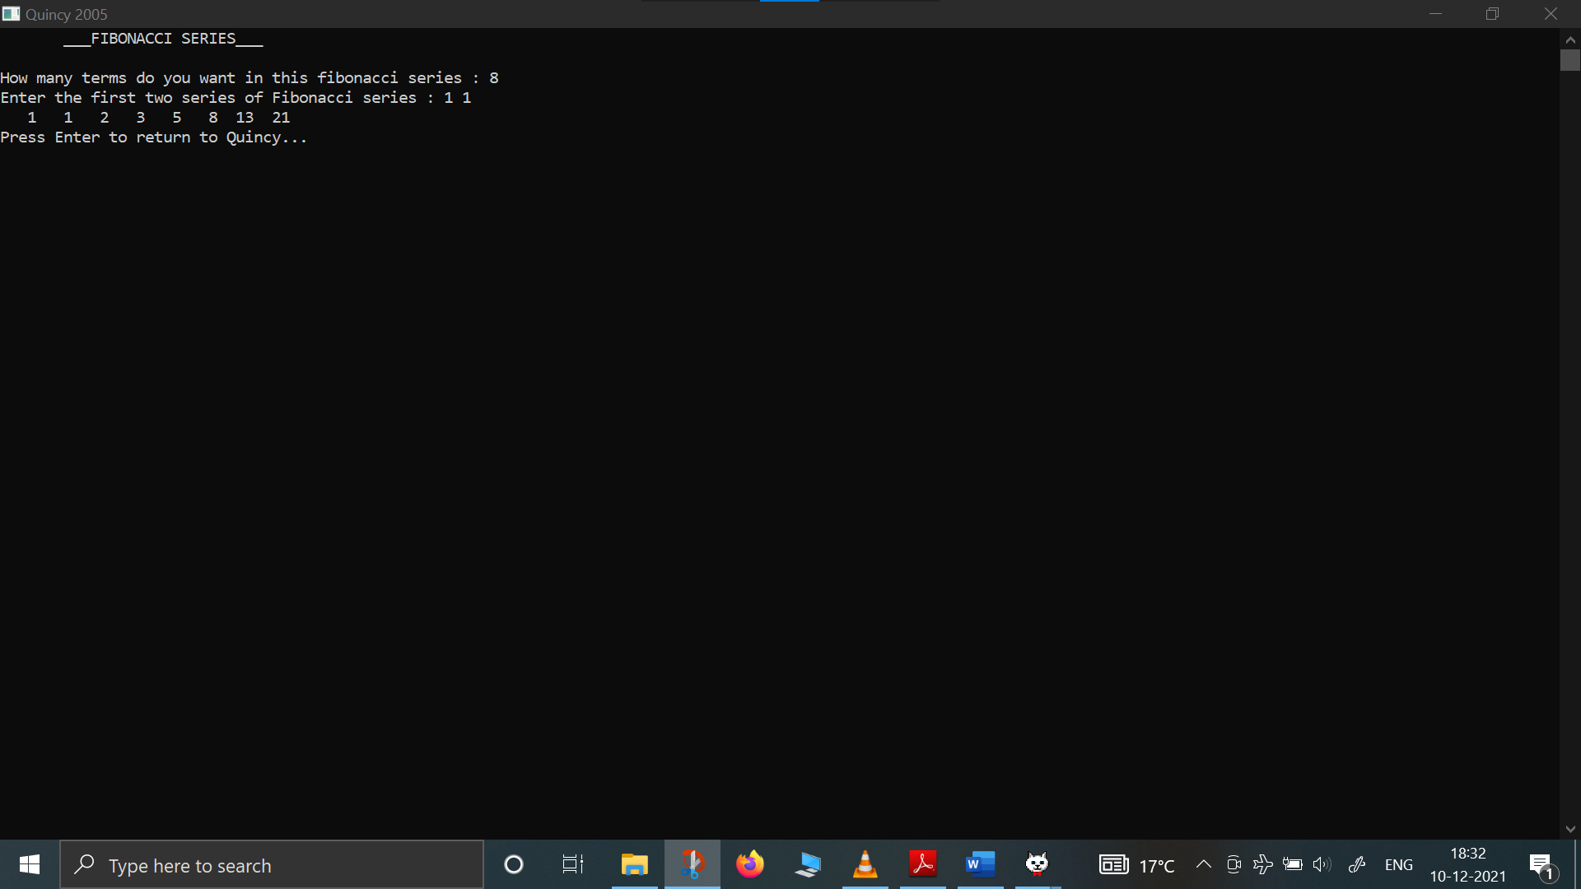

**#5- WAP to display the sum of all even and odd numbers between 1 to n:**

#include<iostream>

#include<iomanip>

using namespace std;

int main(){

int num;

int sumOdd=0;

int sumEven=0;

cout<<setw(50)<<"* CALCULATE THE SUM OF ODD AND EVEN NUMBERS *"<<endl;

cout<<"\nThis program calculates the sum of all odd and even numbers from 1 to n."<<endl;

cout<<"Enter the value of n : ";

cin>>num;

int i=0;

while (i<=num){

if (i%2==0){

sumEven=sumEven+i;

}

else{

sumOdd=sumOdd+i;

}

i++;

}

cout<<"\nThe SUM of EVEN NUMBERS from 1 to "<<num<<" is "<<sumEven<<endl;

cout<<"\nThe SUM of ODD NUMBERS from 1 to "<<num<<" is "<<sumOdd<<endl;

return 0;

}

